Week 6
Module 10

Prb5:
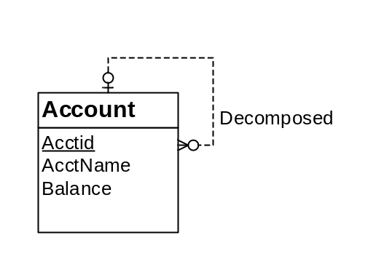

Account (Acctid, AcctName, Balance, Decomposer)
FOREIGN KEY (Decomposer) REFERENCES Account

